MERIT DAY PROGRAMME REPORT 2026
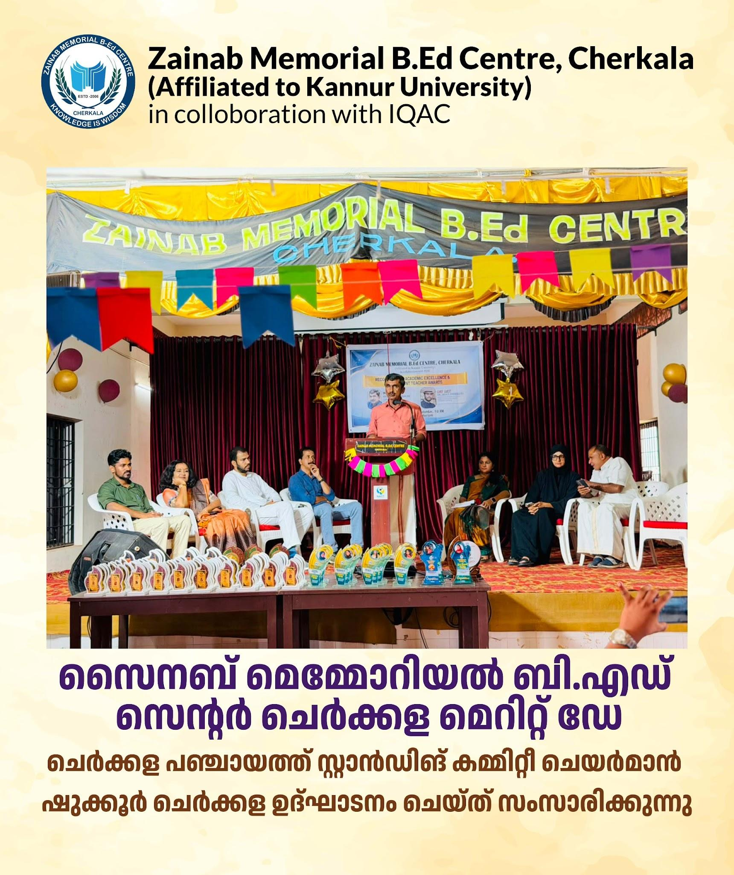
Zainab Memorial B.Ed Centre, Cherkala
(Affiliated to Kannur University)
In Association with IQAC
Date: 13 June 2026 | Time: 10:00 AM
Zainab Memorial B.Ed Centre, Cherkala, in association with IQAC, organized the Merit Day Programme on 13 June 2026 at 10:00 AM to recognize and celebrate the academic achievements of students. The programme aimed to honour students who excelled in competitive examinations and university examinations and to inspire others to strive for academic excellence.
The programme began with a prayer by the College Team, followed by a welcome address by Mr. Shafeeque O.M., Assistant Professor of Social Science. The function was presided over by Dr. Neena M.K., Principal, who congratulated the award winners and emphasized the importance of dedication and lifelong learning. Mrs. Haseena Aboobacker, College Director, delivered the Directorial Speech, appreciating the efforts of students and faculty members.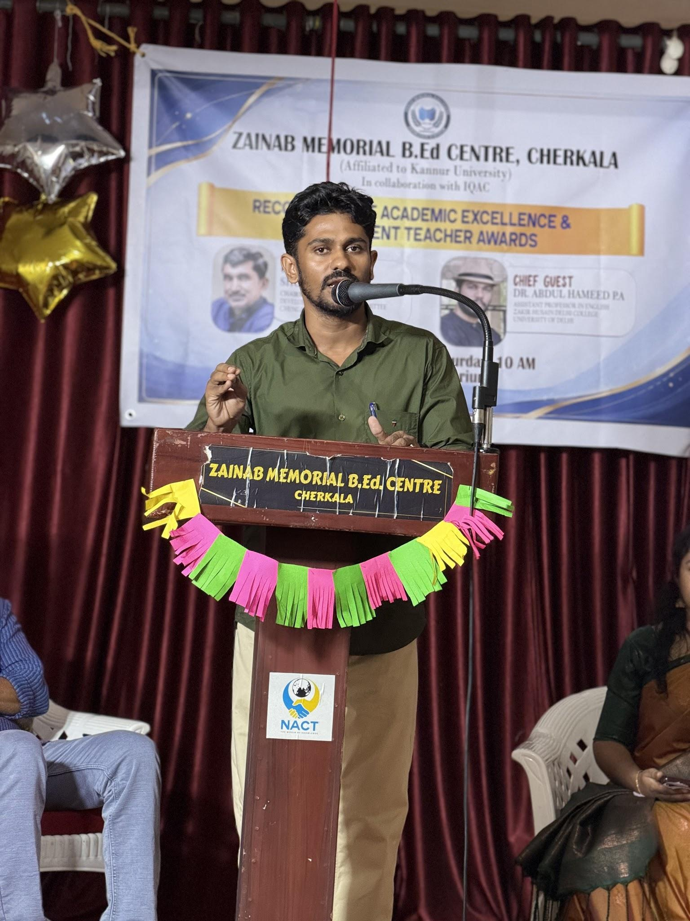
The programme was inaugurated by Mr. Shukkoor Cherkalam, Chairman, Development Standing Committee, Chengala Grama Panchayath. A major highlight of the event was the Merit Award Distribution Ceremony. Awards and certificates were presented to K-TET qualified students, SET and CTET holders, university distinction holders, and the Best Student Teacher in recognition of their outstanding academic and professional achievements. The awardees were appreciated for their dedication, hard work, and contribution to the institution’s reputation.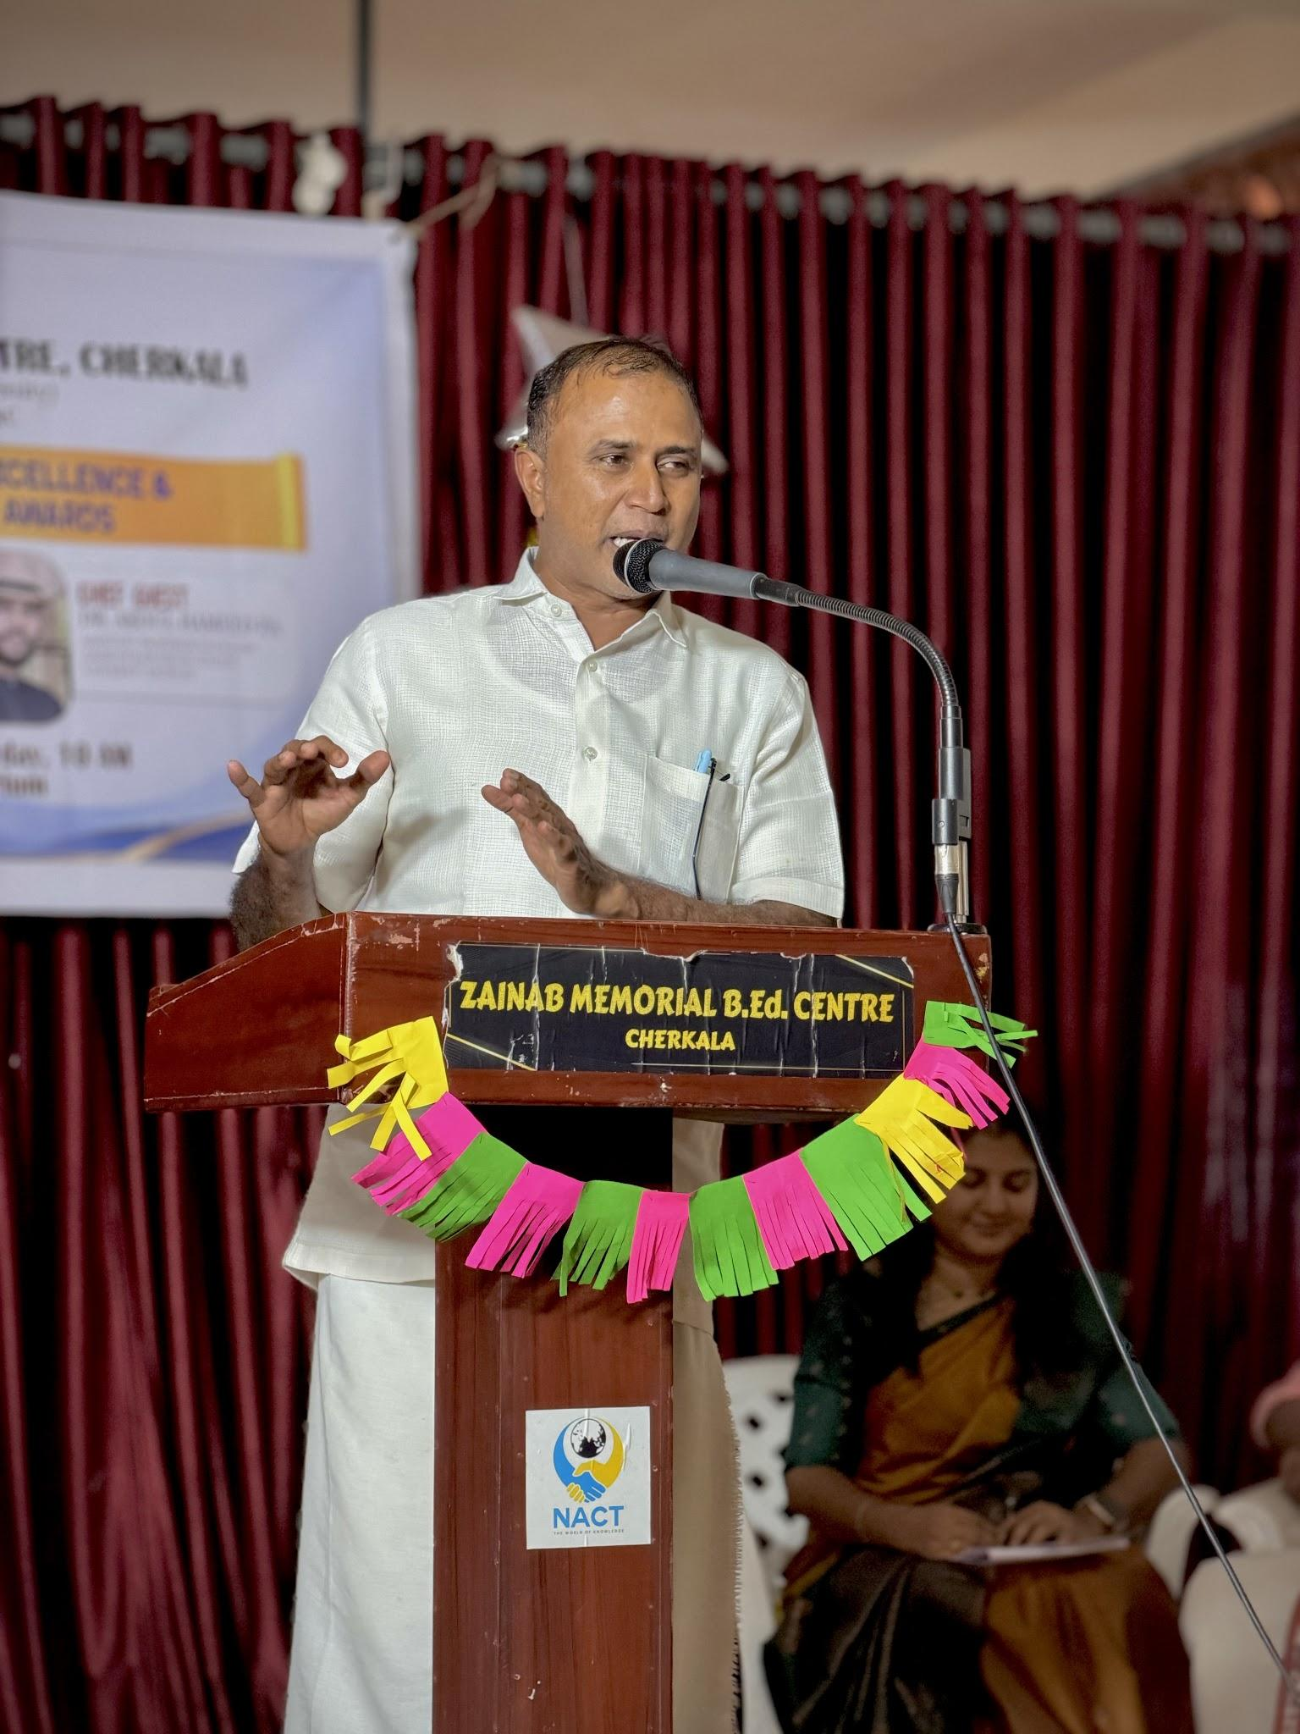
The Chief Guest, Dr. Abdul Hameed P.A., Assistant Professor in English, Zakir Husain Delhi College, University of Delhi, delivered an inspiring keynote address. Felicitations were offered by Mr. Muneer P. Cherkalam, PTA Vice President, and Mrs. Aleena L. Sunny, Staff Advisor.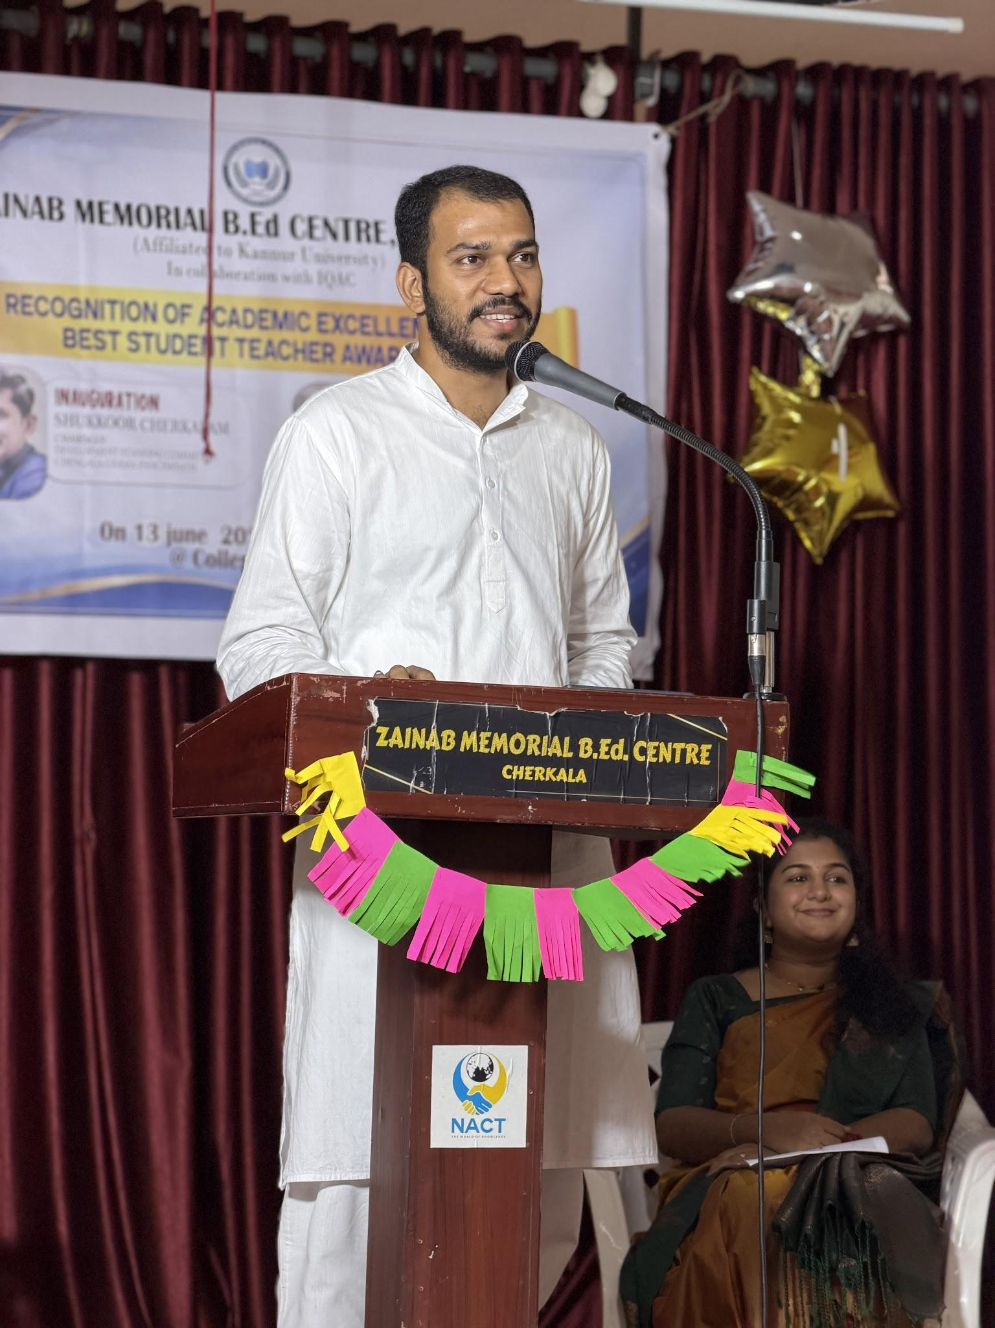
The programme concluded with a Vote of Thanks by Mr. Ganesan P.V., Assistant Professor of General Education. The event was a grand success and effectively promoted academic excellence among students.

