REPORT ON NET COACHING PROGRAMME

(GENERAL PAPER)
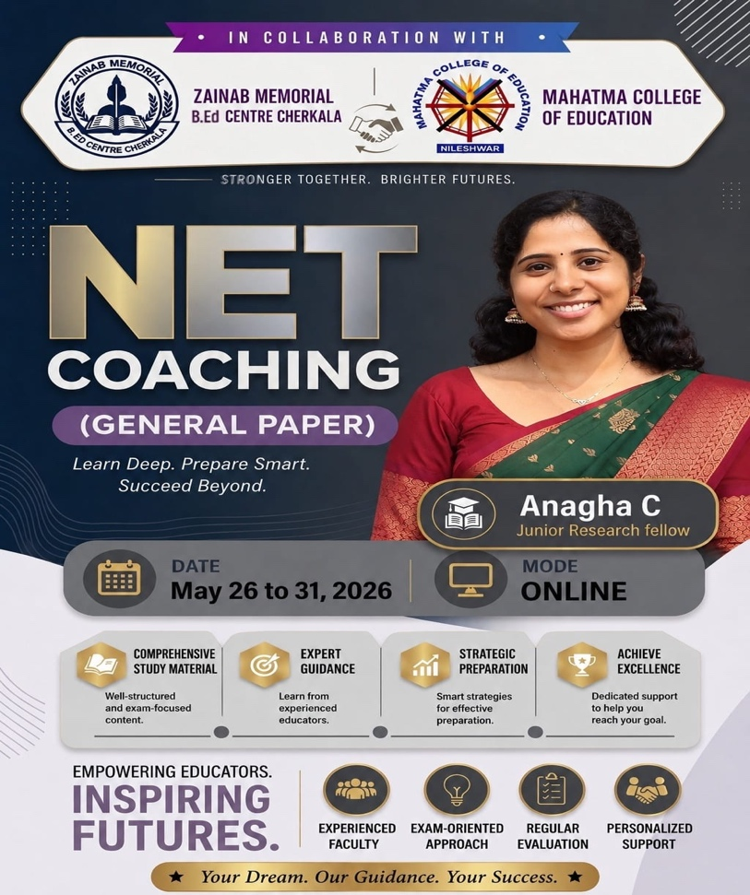
A one-hour online coaching session on UGC-NET General Paper was conducted from 26 May 2026 to 1 June2026 from 7:30 PM to 8:30 PM as part of the NET Coaching Programme jointly organised by Zainab Memorial B.Ed Centre, Cherkala and Mahatma College of Education, Nileshwar. The programme aimed to equip aspiring NET candidates with the knowledge, skills, and strategies required to perform effectively in the UGC-NET examination.
The session was handled by Ms. Anagha C, Junior Research Fellow, who served as the resource person. Through her expertise and systematic presentation, she provided valuable insights into the structure of the examination and the methods to approach different sections of the General Paper.
The session commenced at 7:30 PM with a brief introduction to the objectives of the coaching programme. The resource person highlighted the significance of the UGC-NET examination for aspiring educators and researchers and emphasised the importance of strategic preparation.
Ms. Anagha C provided a comprehensive overview of the UGC-NET General Paper (Paper I), explaining its role in assessing candidates’ teaching and research aptitude, reasoning ability, comprehension skills, and general awareness. She discussed the examination pattern, marking scheme, and the importance of time management during the examination.
The resource person then elaborated on various topics included in the syllabus. She explained the concepts of Teaching Aptitude, focusing on levels of teaching, characteristics of effective teaching, learner-centered education, and evaluation techniques. Different teaching methods such as lecture, discussion, project work, seminars, brainstorming, and role play were discussed in detail.
The session also covered Research Aptitude, where the participants were introduced to the nature and characteristics of research, types of research, research ethics, and the importance of systematic inquiry in academic work. The resource person stressed the role of research in knowledge generation and professional development.
A significant portion of the session was devoted to Mathematical Reasoning and Quantitative Aptitude. Topics such as percentages, ratio and proportion, profit and loss, discount, simple interest, compound interest, averages, and data interpretation were explained with examples. The resource person demonstrated problem-solving techniques and shared useful shortcuts that could help candidates solve questions quickly and accurately during the examination.
The discussion on Logical Reasoning focused on arguments, assumptions, conclusions, analogies, coding-decoding, and analytical thinking. Participants were guided on how to identify patterns and apply logical approaches to solve reasoning questions effectively.
The resource person further addressed Data Interpretation, explaining how to analyze and interpret information presented through tables, graphs, and charts. She emphasized the need for accuracy and careful observation while dealing with numerical data.
Another important area covered during the session was Higher Education System in India. Ms. Anagha C discussed the evolution of higher education, major educational commissions and committees, Choice Based Credit System (CBCS), MOOCs, SWAYAM, and various educational reforms. These topics were presented in a concise and examination-oriented manner.
The session also introduced participants to important educational concepts. The resource person highlighted frequently asked areas in previous NET examinations and advised participants to prioritize those topics during preparation.
The session was interactive one. Participants actively engaged in discussions and sought clarification regarding difficult topics and examination strategies. The resource person patiently answered questions related to syllabus coverage, preparation techniques, study materials, and time management. Her practical suggestions helped participants gain confidence in approaching the examination systematically.The interactive nature of the programme enabled participants to better understand the requirements of the examination and identify areas that required further improvement.
The NET Coaching Programme was highly informative and beneficial. The session provided participants with a clear understanding of the UGC-NET General Paper and offered practical guidance for effective examination preparation. Her detailed explanations, interactive approach, and examination-oriented strategies made the session engaging and productive.
The programme successfully enhanced the participants’ knowledge, confidence, and readiness for the UGC-NET examination. It served as a valuable learning experience and motivated aspiring candidates to pursue their preparation with greater dedication and determination.

