Report on Food Kit Distribution Programme by NSS Unit 202
As part of NSS Unit 202 of Kannur University, the student volunteers of Zainab Memorial B.Ed Centre organised a food kit distribution programme on 18 March 2026 from 1:30 PM to 3:00 PM at Chengala Grama Panchayat near Pady, Kasaragod.
During the programme, more than 30 food kits were distributed to the needy in the locality. Most of the beneficiaries were from economically weaker sections, including people supported under the Government’s Life Mission scheme and other poor families. The distribution was carried out in an organised manner to ensure that the support reached deserving individuals.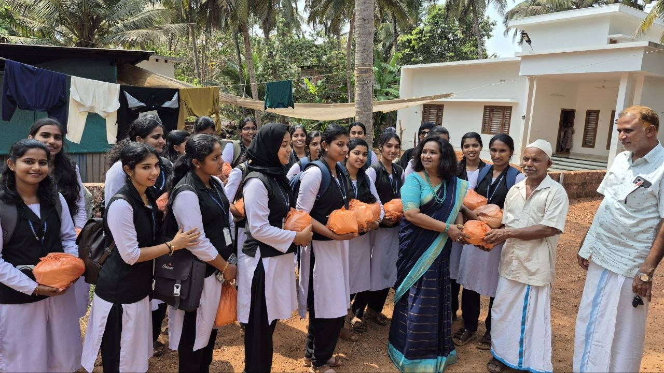
The programme was led by Mr. Muneer P. Cherkala, President of the PTA, who played a crucial role in identifying the location and coordinating local arrangements. The programme was supported by Ms. Haseena, Director of the college, who contributed generously both financially and non-financially for the successful conduct of the activity. Programme Officer Mr. Biju and Principal Dr. Neena also played significant roles in planning and executing the programme.
The NSS volunteers actively participated in organising and distributing the food kits. The activity provided them with an opportunity to engage directly with the community and understand social realities. It helped in developing a sense of responsibility, empathy, and teamwork among the volunteers.
The programme was beneficial to the recipients as it provided essential food support and brought a sense of care and inclusion. Overall, the initiative was successful and reflected the true spirit of NSS by promoting social service and community engagements.

